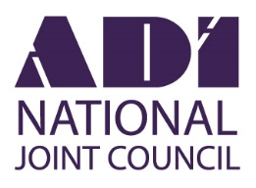
ANNUAL CONFERENCE 2018

8.30 Registration opens, coffee & trade stands open

9.30 Opening Address – Neil Peek ADINJC President
Welcome from Lynne Barrie ADINJC Chairman

9.40 Adam Bragg SmartDriving – Why are we here?

10.05 Adrianne Carter – The Face Whisperer
Decoding the face for success: Driving Instructors

10.40 Alan Hiscox – Safer Drivers, Safer Riders, Safer Horses

11.05 Coffee & comfort break

11.35 Jacqui Turland DVSA Registrar of ADIs and
John Sheridan, Driver Training Policy Manager

DVSA Question Time and updates

12.35 Lunch (details on your badge) and trade stands

1.55 Steve Proctor – How Safe are our roads for cyclists?

2.35 Ian McIntosh – CEO RED Driving School
Autonomous Vehicles and the Driving Tuition Business

3.15 Comfort break and refreshments

3.40 MPS Oliver Tayler QPM – The Honest Truth

First Call to Crown Court: A fatal RTC enquiry and could effective education have avoided it?

4.15 Raffle Draw

4.30 Conference Closes.
May we wish you a safe journey home and remind you to save the date for 2019, October 6th

*Programme may be subject to change

