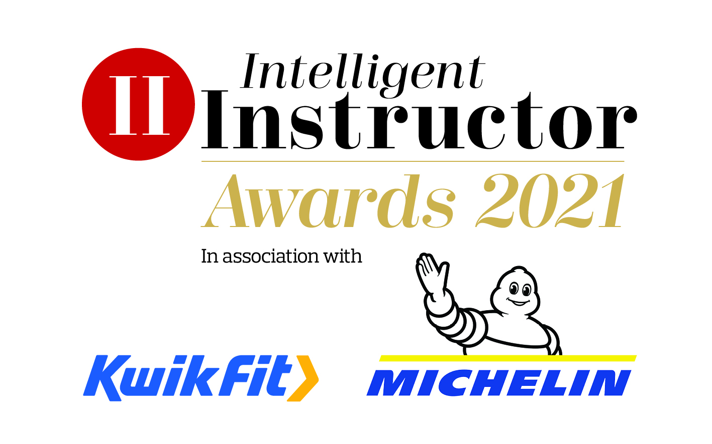
Driving Instructor of the Year

We all know how important our driving instructor is to us. They teach us one of the few life skills which sets us up for many years of independent driving, giving us that much needed freedom at a key point in our lives.

We know that you’re at the very beginning of your driving journey, be that currently learning or have recently passed and therefore we are approaching you to help us identify Britain's ‘Driving Instructor of the Year’, along with 12 regional winners.

If you have had a great experience with your instructor who you think are worthy of winning this award, we’d like to hear from you. We are asking you to spare a few minutes of your time to help nominate your instructor by providing information across four specific areas.

To give them the best chance of being in with a chance of winning, please be as detailed as you can on the nomination form by the closing date of 10th January 2021.

Thanks, in advance for nominating your instructor.

(Fields to fill in)
Driving instructor name:
Driving school (if applicable):
Driving instructor email address:
Driving instructor mobile number:
Region: (drop down, tick one box)
- East Midlands
- East of England
- London
- North East
- North West
- Northern Ireland
- Scotland
- South East
- South West
- Wales
- West Midlands
- Yorkshire and The Humber

- Making learning to drive interesting
How does your instructor put you at the centre of what they do and to make you feel important? Do they keep in touch between lessons, maybe via online engagement? How easy is it to book lessons? Do they help you prepare for the theory and hazard-perception tests? Do they offer post-test training?

[BOX FOR ENTRANT TO TYPE COPY – 50 words max]

- Innovative teaching methods
Is your instructor innovative and effective in their teaching? Do they use engaging teaching techniques, if so, provide examples of this and how they have done this - courses, books, articles, etc. Do they engage with your parents, use interesting and fun ways for you to learn to drive? Do they use clever tactics to put you at ease and to overcome any fears you may have?

[BOX FOR ENTRANT TO TYPE COPY – 50 words max)

- Road safety
Does your instructor educate you about certain dangers to be aware as a new driver? May this include attitude and behaviour training, follow-up work with you, providing or suggesting extra learning resources and/or a commitment to post-test training.

[BOX FOR ENTRANTS TO TYPE COPY – 50 words max]

- Additional information
Please surmise why this person is such a good instructor. Please tell us how your instructor went above and beyond the call of duty and why they should be an award winner.

[BOX FOR ENTRANTS TO TYPE COPY – 100 words max]

SUBMIT

