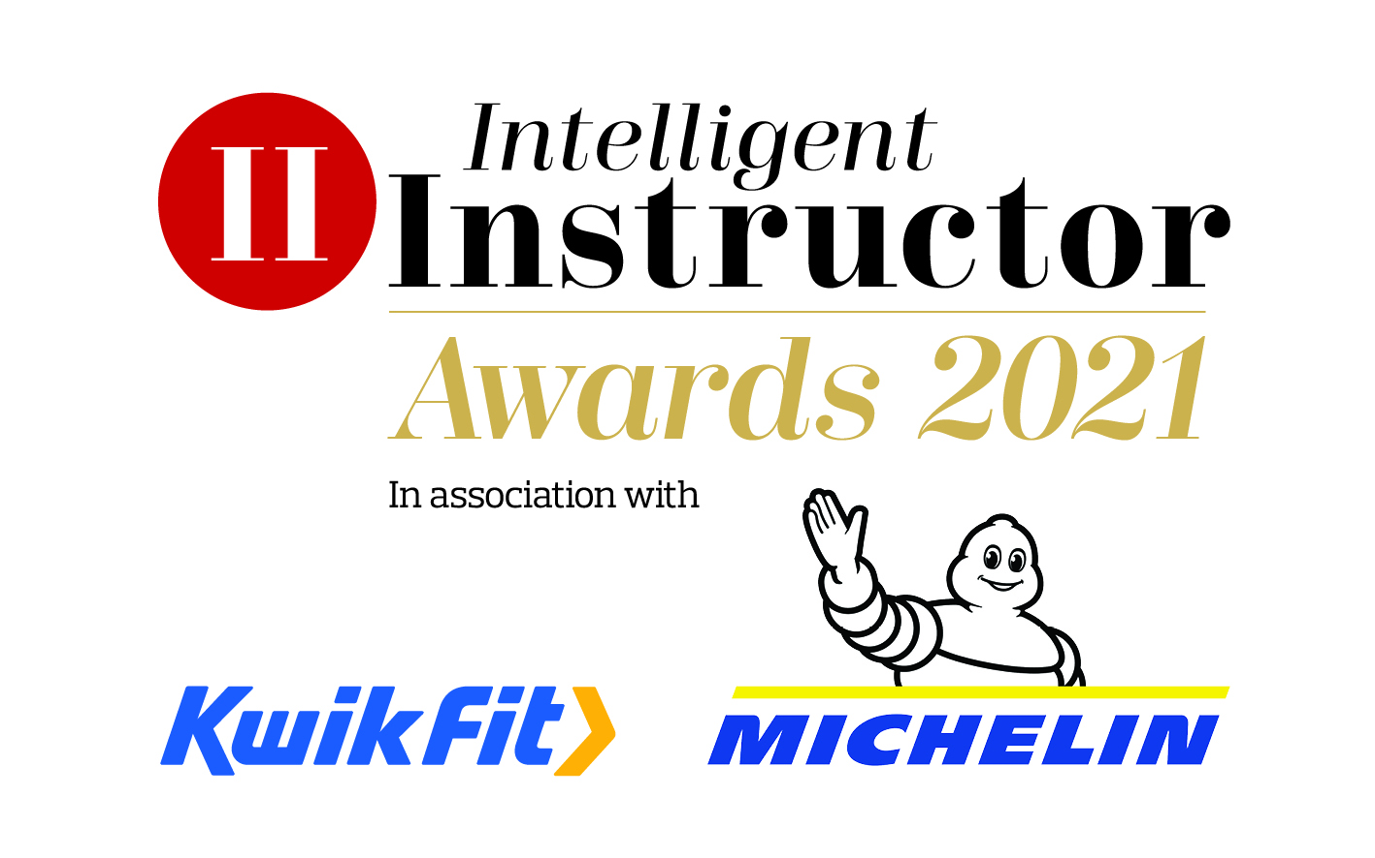
Product of the Year 2021 sponsored by Kwik Fit and Michelin

Name of product nominated:

Contact name:
Position:
Organisation:
Telephone number:
Email address:

NB. The synopsis and logo/image will be showcased on the Intelligent Instructor Awards voting portal for the public to view.

50-word award entry synopsis:
Supporting logo/image to be attached with entry: (high resolution, 300dpi jpeg or png file, square or landscape)

Please limit your entry to no more than 1,000 words. You can submit a maximum of three A4 pages of supporting documents too. Marks will be awarded, out of 10, for each of the four headings below, by each of our judging panel, on how well you meet each part of the criteria.

- Product description
Please describe your technology / software / physical product in detail, including its key functionality and how this benefits the ADI and/or new driver. What are its USPs? How do you tailor the product to suits its target market?

- Innovation
How have you adapted during the pandemic to suit the customer needs? How have you developed your offering to meet today’s modern needs? What improvements have you made in the last 12 months to help make your product better and better tailored for your market? What plans have you to invest/improve it in the future? How do you keep one step ahead of the competition?

- Success
How do you measure the product’s success? What user feedback has been received? Please provide any independent customer ratings reviews. How are sales tracking over the past 12 months and from launch? Does your product help ADIs improve the learning to drive experience, keep learners safe and/or encouraging better driving?

- Additional information
Please include any further information which you think makes you stand out from others. How you have adapted to the challenges faced during Covid-19, both internally as a business and importantly how responsive have you been to the instructors’ needs during this challenging time?
Closing date 10th January 2021.

