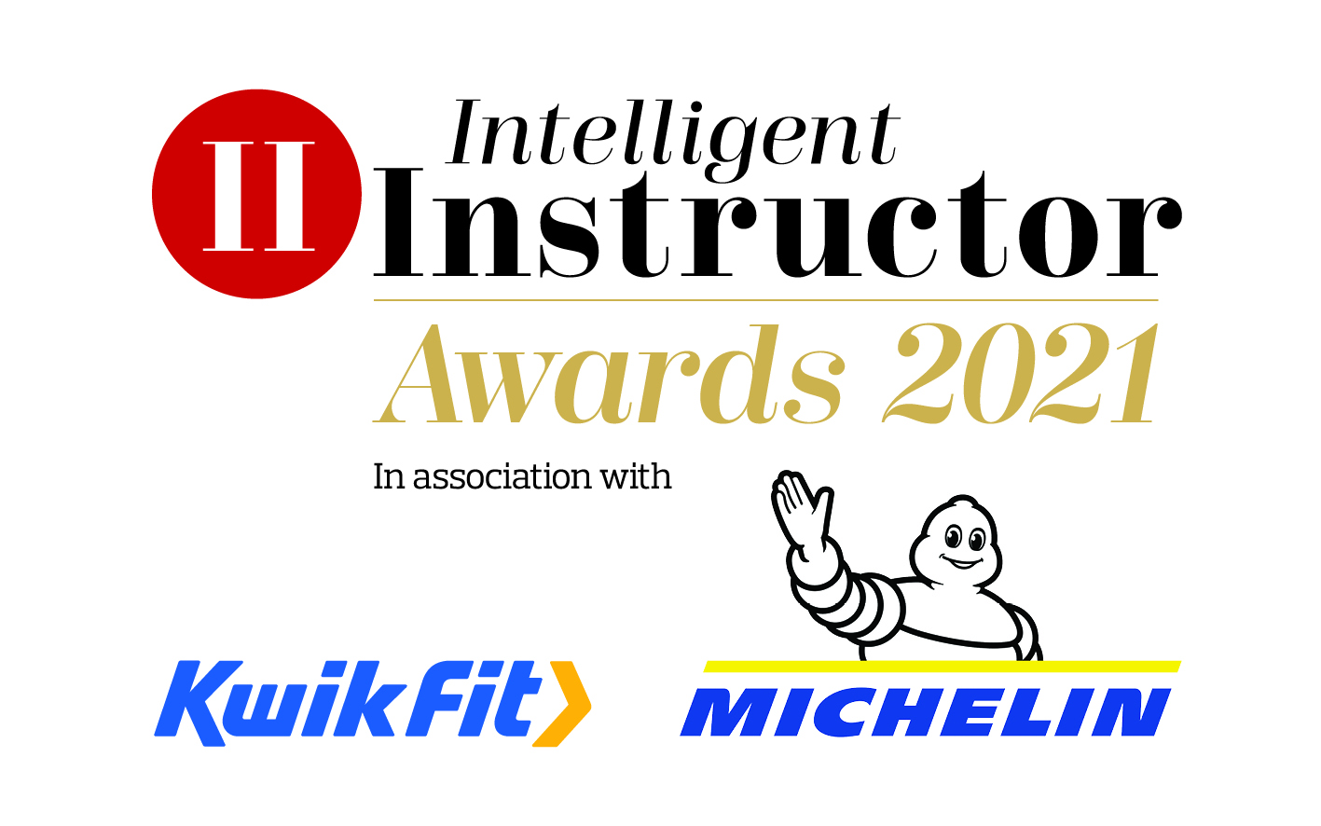

Services to the Driver Training Industry Award

Individual nominated:
Position:
Organisation:
Telephone number:
Email address:

Nominator contact information (if different from above)
Contact name:
Position:
Organisation:
Telephone number:
Email address:

Relationship to nominee:

For this award, we are looking for an entry of no more than 250 words, with a maximum of three A4 pages of supporting documents.

Closing date 10th January 2021.

