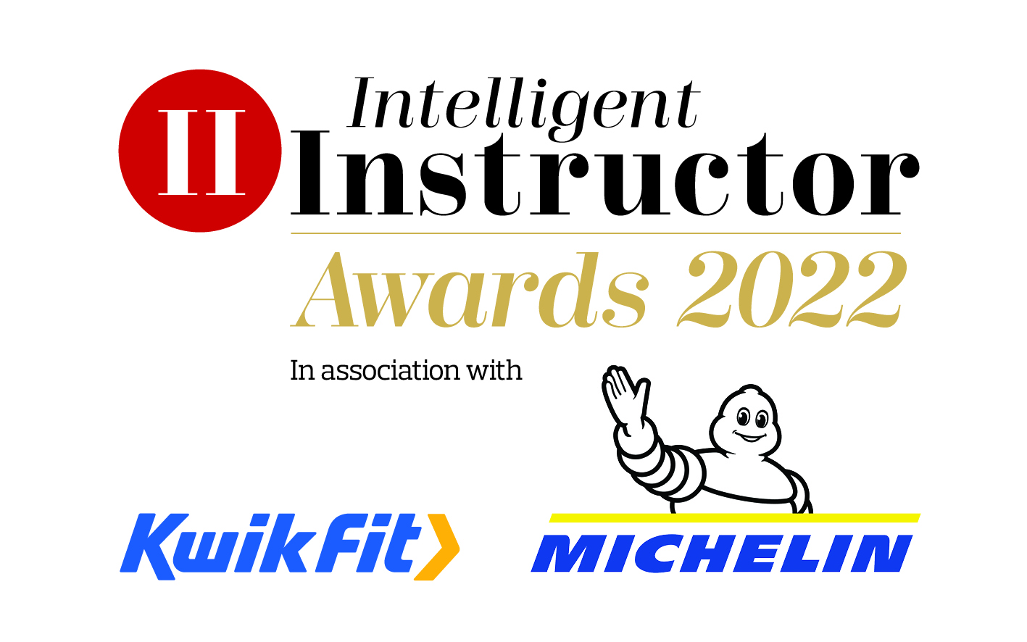
Driving Instructor Insurer of the Year

Insurance company nominated:
Contact name:
Position:
Organisation:
Telephone number:
Email address:

NB. The synopsis and logo will be showcased on the Intelligent Instructor Awards voting portal for the public to view.

50-word award entry synopsis:

Supporting logo to be attached as a separate file with entry: (high resolution, 300dpi jpeg or png file, square or landscape)

Please limit your entry to no more than 1,000 words. You can submit a maximum of three A4 pages of supporting documents too. Marks will be awarded, out of 10, for each of the five headings below, by each of our judging panel, on how well you meet each part of the criteria.

- USP
Concisely describe your insurance product and how does it differ from others? What makes you stand out from the rest in this competitive market? What three attributes set you apart? Why should an instructor choose your product?

- Innovation
How have you developed your products and service to meet today’s modern needs? What technological advancements have you made in the last 12 months to help make your offering more efficient and the customer experience better?

- Marketing
What proven methods of engagement do you use to target instructors? What successes have you had? What specific marketing initiatives have been undertaken to attract instructors? What is our social media strategy? How strong is your brand? What type and how often do you conduct market research? How do you communicate with your customers, present and past?

- Customer service
Please provide evidence of customer satisfaction, either through independent reviews (e.g. Google or Feefo), customer testimonials and/or real-life examples. What is your customer retention rate? How does your sales team’s approach ensure engagement with instructors? How quickly and efficiently do you deal with claims? How quickly and efficiently do you deal with complaints? Typically, how soon does the instructor get back on the road in the event of their car being seriously damaged?

- Additional information
Please include any further information which you think makes you stand out from others. How you have adapted to the challenges faced during Covid-19, both internally as a business and importantly how responsive have you been to the instructors’ needs during this challenging time. How quickly did you adapt? How communicative were you to your customers? What level of support di you offer and now flexible and understanding were you?

Entries are to be submitted via email to awards@intelligentinstructor.co.uk

Closing date 2nd December 2021.

