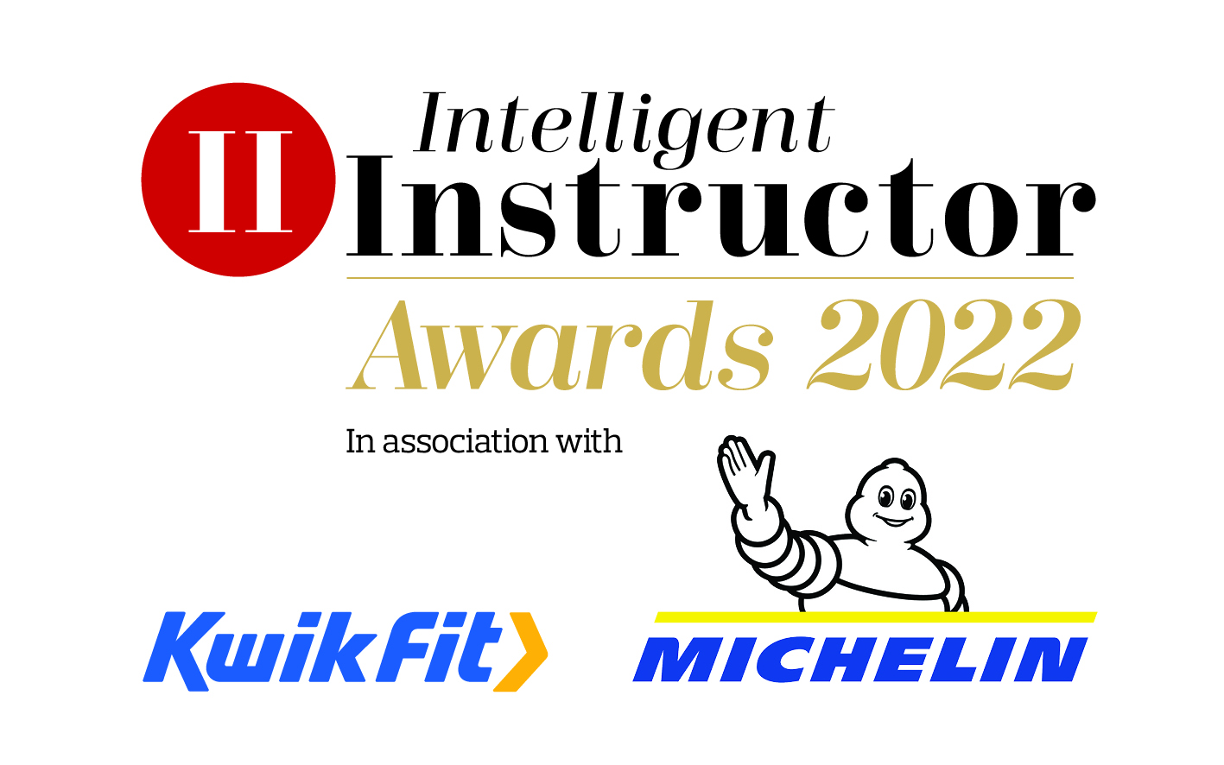
Local Driving Instructor Association of the Year

Local driving instructor association nominated:
Contact name:
Position:
Organisation:
Telephone number:
Email address:

NB. The synopsis and logo will be showcased on the Intelligent Instructor Awards voting portal for the public to view.

50-word award entry synopsis:

Supporting logo to be attached as a separate file with entry: (high resolution, 300dpi jpeg or png file, square or landscape)

Please limit your entry to no more than 1,000 words. You can submit a maximum of three A4 pages of supporting documents too. Marks will be awarded, out of 10, for each of the six headings below, by each of our judging panel, on how well you meet each part of the criteria.

- Philosophy
Please describe your ethos behind your local association. How long has the association been running and what is covered off when you meet? What are your key objectives to your association?

- Engagement
How often to do you meet? How well attended are your meetings? What are the key benefits for attending for members? How do you recruit and welcome new members? What methods of communication do you use to communicate with both member and non-members?

- Effectiveness
What positive actions can be attributed to your local association work? How much community work do you get involved with? What is the biggest single benefit of being a member?

- A commitment to road safety
Road safety is at the core of all driving instruction. We're looking for associations that help promote and encourage road safety engagement, going beyond the high standards expected of this profession.

- Support
What range of support services do you offer your instructors? How much lobbying do you do with the national associations? How you have adapted to the challenges faced during Covid-19 and what support have you offered to your members’ needs during this challenging time.

- Additional information
Please include any further information which you think makes you stand out from others.
Entries are to be submitted via email to awards@intelligentinstructor.co.uk

Closing date 2nd December 2021.

