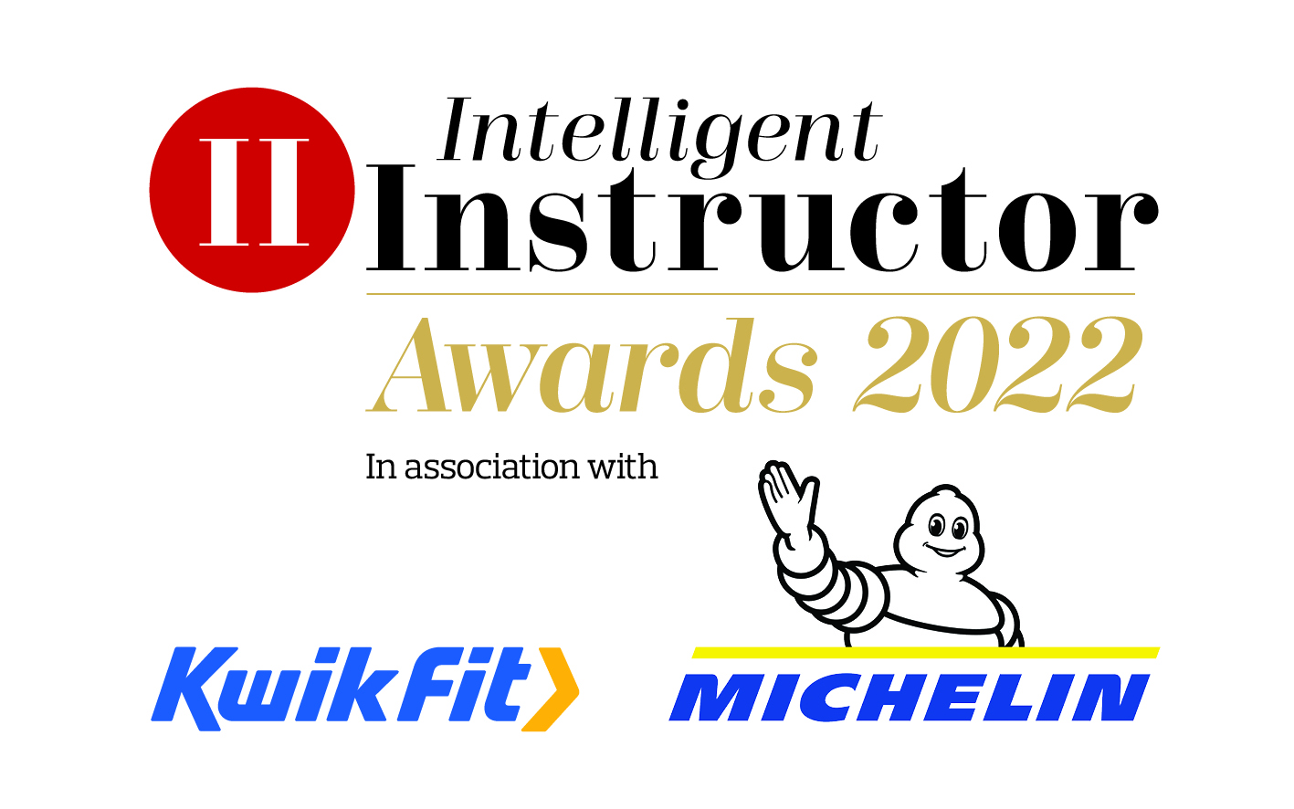
National Driving School of the Year

National driving school nominated:
Contact name:
Position:
Organisation:
Telephone number:
Email address:

NB. The synopsis and logo will be showcased on the Intelligent Instructor Awards voting portal for the public to view.

50-word award entry synopsis:

Supporting logo to be attached as a separate file with entry: (high resolution, 300dpi jpeg or png file, square or landscape)

Please limit your entry to no more than 1,000 words. You can submit a maximum of three A4 pages of supporting documents too. Marks will be awarded, out of 10, for each of the six headings below, by each of our judging panel, on how well you meet each part of the criteria.

- Excellent customer service
Please describe your driving school's approach to customer service. This could include ease of booking, marketing methods used, value for money, independent and verifiable customer satisfaction scores, and customer satisfaction surveys and testimonials. How open are you to their ideas and suggestions?

- Innovative and effective instruction
Successful entrants will need to demonstrate a commitment to creative, effective and supportive instruction. This could include pre-17 driver training options and post-test training, theory test and hazard perception test support, engagement with parents of young learners, original instruction techniques, and follow-up work with pupils.

- A commitment to road safety
Road safety is at the core of all driving instruction. We're looking for driving schools that go beyond the high standards expected of this profession. This could include attitude and behavioural training, follow-up work with students, providing or suggesting extra learning resources, a commitment to post-test training, active membership of road safety organisations and/or linking up with your local road safety team. Does your driving school support your instructors and actively encourage them to look beyond ‘teaching to the test’, providing them with encouragement and resources that will enable them to actively provide more and better road safety awareness and understanding to their pupils?

- Strong business development
Our judges are looking for driving schools with a plan to build and develop their business. Please provide evidence that you are planning for a successful and sustainable future. This could include your business's environmental commitment, professional presentation/dress codes, examples of business growth, innovative marketing methods.

- Support for instructors
Small, medium and large schools are only as good as their instructors. Please describe how your school values its instructors and helps them in developing their skills and forwarding their career. This could include business support (both paid and inclusive), investment in CPD, accountancy services, loyalty schemes and bonuses, and value for ADIs. Do they encourage you to attend the industry events, support your new initiatives and ideas? How you have you supported your franchisees during Covid-19, both internally as a business and importantly how responsive have you been to the instructors’ needs during this challenging time. How well have to communicated and being understanding of your franchisees’ problems during lockdown?

- Additional information
Please include any further information which you think makes you stand out from others.

Entries are to be submitted via email to awards@intelligentinstructor.co.uk

Closing date 2nd December 2021.

