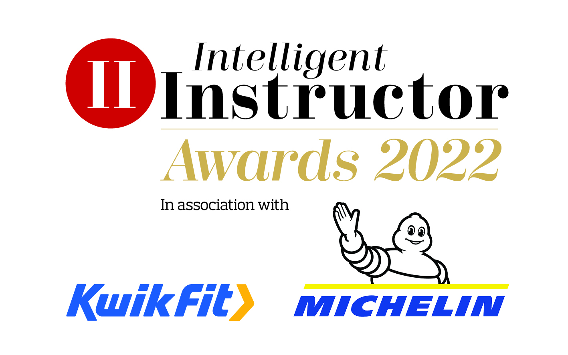
Professional Support Provider of the Year

Name of professional support provider nominated:

Contact name:
Position:
Organisation:
Telephone number:
Email address:

NB. The synopsis and logo will be showcased on the Intelligent Instructor Awards voting portal for the public to view.

50-word award entry synopsis:

Supporting logo to be attached as a separate file with entry: (high resolution, 300dpi jpeg or png file, square or landscape)

50-word award entry synopsis:

Supporting logo to be attached with entry: (high resolution, 300dpi jpeg or png file, square or landscape)

Please limit your entry to no more than 1,000 words. You can submit a maximum of three A4 pages of supporting documents too. Marks will be awarded, out of 10, for each of the six headings below, by each of our judging panel, on how well you meet each part of the criteria.

- Product/service description
Please describe the type of essential professional support you offer to the driving instructor. What are your USPs? How do you differ from others on the market?

- Benefits
How do you help instructors improve their business efficiencies and effectiveness? Do you have real evidence on how you have made a real difference to the instructor? Do you help save them time, money, or both? What is the cost benefit ratio of your product/service?

- Innovation
In light of the pandemic, what changes if any, did you make and how swiftly were you to react? How have you developed your service to meet today’s modern needs? What technological advancements have you made in the last 12 months to help make this service you provide better? How has your offering developed over time in today’s rapidly changing world to remain relevant for the modern instructor? How nimble is your organisation? What are your future plans to remain ahead of the game?

- Success
How do you measure your services success? How quickly are you growing? How are sales tracking over the past 12 months? Does your service help ADIs improve the learning to drive experience, keep learners safe and/or encouraging better driving?

- Customer satisfaction
Please provide evidence of customer satisfaction, either through independent reviews (e.g. Google or Feefo), customer testimonials and/or real-life examples. How quickly and efficiently do you deal with customer issues? How quickly do you deal with enquiries? Do you develop your offering based on customer feedback?

- Additional information
Please include any further information which you think makes you stand out from others. How you have adapted to the challenges faced during Covid-19, both internally as a business and importantly how responsive have you been to the instructors’ needs during this challenging time.
Entries are to be submitted via email to awards@intelligentinstructor.co.uk

Closing date 2nd December 2021.

